PROJECT REPORT
Heritage Treasures: An In-Depth Analysis of UNESCO World Heritage Sites (2019)
A Tableau-Based Business Intelligence Dashboard Project
Project Title | Heritage Treasures: An In-Depth Analysis of UNESCO World Heritage Sites (2019)
Domain | Culture & Heritage Analytics / Tourism & Conservation Business Intelligence
Tool | Tableau Desktop / Tableau Public
Dataset | Kaggle UNESCO World Heritage Sites Dataset, 1978–2019 (~1,121 sites, 12 fields)
Prepared By | M. Deepika (Team Lead), M. Supraja, K. Srikala, I. Pushpa, U. Bhavana
Mentor | Not yet assigned
GitHub Repository | https://github.com/mankudeepika123-rgb/Heritage-Treasures-An-In-Depth-Analysis-of-UNESCO-World-Heritage-Sites-2019-
Tableau Public Link | https://public.tableau.com/app/profile/manku.deepika5282/viz/HeritageTreasuresAnIn-DepthAnalysisofUNESCOWorldHeritageSites2019/UNESCOSiteOverviewDangerSitesAnalysis
Date | 22/08/2026

Project Context
This report presents a comprehensive interactive exploration of UNESCO's World Heritage List using 41 years (1978–2019) of site inscription data covering approximately 1,121 sites. Four Tableau visualizations — a World Map by Danger Status, a Category Distribution chart, a Region-wise Danger Ranking chart, and an Inscription Trend line — are combined into three role-specific dashboards and a three-point guided Story, enabling stakeholders to uncover geographic and historical patterns and make data-driven conservation, tourism, and policy decisions.
By harnessing the power of Tableau, this report presents the data in a visually appealing, interactive form that lets readers explore the state of global heritage protection for themselves.

Scenario 1: Heritage Conservation Officer
Elena is a conservation officer at a heritage protection agency responsible for flagging at-risk World Heritage Sites. However, she struggles to quickly justify where conservation funding should go first because Danger List data is scattered across UNESCO committee reports with no single visual view by region or cause. By analysing 41 years of UNESCO World Heritage Sites data, Elena needs a ranked, regional view of danger-listed sites to prioritise funding requests with confidence. The Conservation Officer Dashboard serves Elena through the World Map by Danger Status and the Region-wise Danger Ranking chart.

Scenario 2: Cultural Tourism Planner
Marcus is a tourism board planner designing heritage tourism circuits across regions and site categories. He needs to understand how sites are distributed by category and region so he can plan balanced itineraries, but category and country-level site counts are currently buried in long reference tables rather than visualised. Using Tableau dashboards, he aims to compare regions and categories at a glance to design tourism circuits that reflect the true spread of Cultural, Natural, and Mixed sites. The Tourism Planner Dashboard serves Marcus through the World Map and the Category Distribution chart.

Scenario 3: Heritage Policy Researcher
Amara is a policy researcher studying global patterns in World Heritage recognition and protection over time. She needs to understand how inscription trends and danger patterns have evolved from 1978 to 2019, but yearly inscription and danger-listing data exists without being plotted as a trend over time. By leveraging visual analytics in Tableau, Amara seeks to communicate long-term heritage trends to policymakers with clear, evidence-based charts. The Policy Researcher Dashboard serves Amara through the Inscription Trend chart and a Danger List timeline by year.
Contents
1. Introduction
1.1 Project Overview
1.2 Purpose
2. Ideation Phase
2.1 Problem Statement
2.2 Empathy Map Canvas
2.3 Brainstorming
3. Requirement Analysis
3.1 Customer Journey Map
3.2 Solution Requirement
3.3 Data Flow Diagram
3.4 Technology Stack
4. Project Design
4.1 Problem – Solution Fit
4.2 Proposed Solution
4.3 Solution Architecture
5. Project Planning & Scheduling
5.1 Project Planning
6. Functional and Performance Testing
6.1 Performance Testing
7. Results
7.1 Output Screenshots
8. Advantages & Disadvantages
9. Conclusion
10. Future Scope
11. Appendix

1. Introduction

1.1 Project Overview
Heritage Treasures: An In-Depth Analysis of UNESCO World Heritage Sites is a team Tableau business intelligence project built on 41 years (1978–2019) of the Kaggle UNESCO World Heritage Sites dataset, spanning approximately 1,121 sites, 12 fields, and every UNESCO region. The dataset was reviewed and standardised before being connected to Tableau Desktop, where four worksheets, three role-specific dashboards, and a three-point guided Story were built and published to Tableau Public for free, browser-based, authentication-free access.
The project was delivered by a five-person team — M. Deepika (Team Lead), M. Supraja, K. Srikala, I. Pushpa, and U. Bhavana — with work distributed across three sprints covering data preparation, visualization and dashboard assembly, and Story development, testing, and documentation.

1.2 Purpose
The purpose of this project is to turn a scattered set of UNESCO reference reports into an accessible decision-support tool for three distinct audiences: heritage conservation officers prioritising funding by region, tourism planners balancing itineraries across site categories, and policy researchers communicating long-term heritage trends. Each audience is served by a purpose-built dashboard view rather than a single generic report, with a guided Tableau Story tying the three perspectives together into one narrative.

2. Ideation Phase

2.1 Problem Statement
Problem statements were derived from three primary personas using an “I am / I'm trying to / But / Because / Which makes me feel” framework.
Field | Persona 1 — Elena (Conservation Officer) | Persona 2 — Marcus (Tourism Planner) | Persona 3 — Amara (Policy Researcher)
I am (Customer) | A conservation officer at a heritage protection agency responsible for flagging at-risk World Heritage Sites | A tourism board planner designing heritage tourism circuits across regions and site categories | A policy researcher studying global patterns in World Heritage recognition and protection over time
I'm trying to… | Identify which sites are on the Danger List and understand why, to prioritise funding requests | Understand how sites are distributed by category and region to plan balanced tourism itineraries | Understand how inscription trends and danger patterns have evolved from 1978 to 2019
But… | Danger List data is scattered across UNESCO reports with no single visual view by region or cause | Category and country-level site counts are buried in long reference tables, not visualised | Yearly inscription and danger-listing data exists but isn't plotted as a trend over time
Because… | No interactive tool ranks regions and countries by number of sites in danger | There is no dashboard comparing Cultural, Natural, and Mixed site counts by country or region | No one has built a timeline view connecting inscription growth with conflict-driven danger listings
Which makes me feel… | Frustrated at not being able to quickly justify where conservation funding should go first | Uncertain about which regions are under-represented in current tourism promotion | Limited in ability to communicate long-term heritage trends to policymakers
Key Takeaway All three personas are blocked by the same root cause: UNESCO World Heritage Site data exists but is not visualised in a way that connects site category, region, danger status, and inscription year. This shared root cause justified a single Tableau workbook serving all three audiences — one shared data model with role-specific dashboards layered on top.

2.2 Empathy Map Canvas
The empathy map below was built for Elena, the Heritage Conservation Officer, whose funding-prioritisation deadline pressure makes her the priority case for the initial design.
Dimension | Content
SAYS | “I need to know which regions have the most sites in danger right now.” / “Conflict-affected countries always seem to dominate the Danger List, but I want to see the numbers.” / “Some categories of sites seem more vulnerable than others.”
THINKS | “Which region should get emergency conservation funding first?” / “Are natural sites more at risk than cultural ones?” / “How has the Danger List changed since 1978?”
DOES | Reviews UNESCO committee reports and PDFs manually / Relies on past cases and news coverage for a sense of risk / Cross-checks danger listings against country conflict data by hand
FEELS | Overwhelmed by scattered UNESCO reporting formats / Uncertain whether funding priorities are backed by current data / Motivated to move to a visual, evidence-based prioritisation process
PAINS | No single interactive view ranking regions/countries by number of sites in danger / Cannot see category-level danger patterns at a glance / Funding priority decisions take longer than they should
GAINS (What Success Looks Like) | A clear visual ranking of regions and countries by sites in danger / Confidence that funding priorities are backed by data / Faster, more consistent conservation planning each cycle
The pains-to-gains mapping shaped two concrete design decisions carried into the final workbook: the Conservation Officer Dashboard intentionally combines only the World Map and the Region-wise Danger ranking chart to avoid overwhelming a first-time user, and every chart uses plain region and category labels rather than technical UNESCO codes.

2.3 Brainstorming, Idea Generation & Prioritization
Step 1 — Problem Selection
Selected problem: ‘How can we help conservation officers, tourism planners, and policy researchers make faster, evidence-based heritage protection and planning decisions using historical UNESCO World Heritage Site data?’
Step 2 — Idea Listing & Grouping
- Build a category-wise site count chart (Cultural vs. Natural vs. Mixed)
- Create a world map showing site locations coloured by danger status
- Develop a region-wise Danger List ranking chart
- Build an inscription-trend line chart showing sites added per year since 1978
- Design role-specific dashboards for the Conservation Officer, Tourism Planner, and Policy Researcher personas
- Combine dashboards into a Tableau Story for a guided, narrative-driven presentation
- Publish to Tableau Public for free, browser-accessible sharing
Step 3 — Idea Prioritization
Idea | Impact | Feasibility | Priority
World map of sites by danger status | High | High | 1
Category-wise site count chart | High | High | 2
Region-wise Danger List ranking chart | High | High | 3
Inscription trend line chart (1978–2019) | Medium | High | 4
Role-specific dashboards (3) | High | Medium | 5
Tableau Story (narrative) | Medium | Medium | 6
Publish to Tableau Public | High | High | 7

3. Requirement Analysis

3.1 Customer Journey Map — Elena (Heritage Conservation Officer)
Stage | Awareness | Consideration | Onboarding | Usage | Decision / Outcome
Actions | Notices Danger List updates seem inconsistent across UNESCO committee reports | Hears about a shared Tableau dashboard covering site categories and danger status | Opens the Tableau Public dashboard for the first time via a shared link | Filters by Region and Category, explores the danger-status map and charts | Recommends conservation funding priorities based on data
Emotions | Frustrated, uncertain | Curious, slightly skeptical | Overwhelmed, then reassured | Engaged, empowered | Confident, relieved
Touchpoints | UNESCO committee PDFs, internal meetings | Colleague recommendation | Tableau Public dashboard (shared link) | Interactive filters: Region, Category, Danger Status | Final conservation funding priority list
The emotional curve dips lowest at Onboarding, then climbs as filters let Elena narrow the view to something personally relevant — confirming that usability and a clean first impression are the difference between abandonment and a confident funding recommendation. Two requirements below were added directly from this map: persistent filter state across dashboard tabs, and a sub-3-second filter response target.

3.2 Solution Requirement
Functional Requirements
FR # | Requirement | Description
FR-01 | Data Connectivity | System shall connect to the Kaggle UNESCO World Heritage Sites dataset (~1,121 sites, 12 fields, 1978–2019)
FR-02 | Category Filter | System shall allow users to filter all visualizations by Site Category (Cultural, Natural, Mixed)
FR-03 | Region / Country Filter | System shall allow filtering by UNESCO Region and by Country
FR-04 | Danger Status Filter | System shall allow filtering / highlighting by Danger List status (In Danger / Not In Danger)
FR-05 | World Map of Sites | System shall display a map of all sites, colour-coded by danger status and sized or filtered by category
FR-06 | Category Distribution Chart | System shall display a chart comparing the count of Cultural, Natural, and Mixed sites
FR-07 | Region-wise Danger Ranking Chart | System shall display a ranked bar chart of regions/countries by number of sites in danger
FR-08 | Inscription Trend Chart | System shall display a line chart of the number of sites inscribed per year from 1978 to 2019
FR-09 | Role-Based Dashboards | System shall combine charts into 3 dashboards: Conservation Officer, Tourism Planner, and Policy Researcher views
FR-10 | Tableau Story | System shall present a guided narrative Story with one story point per persona
FR-11 | Tableau Public Publishing | System shall be published to Tableau Public for browser-based access without login
FR-12 | Tooltip on Hover | All charts shall display Site Name, Country, Category, and Danger Status on hover
Every functional requirement above was verified against the shipped workbook during Performance Testing (Section 6).
Non-Functional Requirements
NFR # | Category | Requirement
NFR-01 | Usability | Dashboard UI shall be navigable by non-technical stakeholders without training
NFR-02 | Performance | All filters shall respond and re-render within 3 seconds on the full site dataset
NFR-03 | Accessibility | Published Tableau Public workbook shall be reachable via a public URL without login or plugin install
NFR-04 | Scalability | Solution architecture shall support new inscription years being appended without redesigning dashboards
NFR-05 | Compatibility | Solution shall render correctly on Chrome, Edge, and Safari, on desktop and Tableau Public mobile view
NFR-06 | Maintainability | Workbook shall be saved as a packaged Tableau workbook (.twbx) for portability

3.3 Data Flow Diagram
The following describes the end-to-end data flow for this project:
- Step 1 — Raw Source: Kaggle UNESCO World Heritage Sites dataset (~1,121 sites, 12 fields, 1978–2019)
- Step 2 — Data Preparation: Fields reviewed for nulls and consistency; Country and Region names standardised
- Step 3 — Calculated Fields: Danger Status flag and Years-Since-Inscription calculated field added to support trend analysis
- Step 4 — Tableau Data Connection: Site-level extract connected as the primary source; Country field assigned Geographic Role for map rendering
- Step 5 — Visualization Layer: Individual chart sheets built (world map, category chart, region danger ranking, inscription trend line)
- Step 6 — Dashboard Layer: 3 role-specific dashboards assembled from the chart sheets with interactive filters
- Step 7 — Story Layer: Tableau Story combining dashboards for a guided presentation
- Step 8 — Publishing: Workbook saved to Tableau Public; shareable URL generated for GitHub submission
Each step is a point where the data could break if skipped: standardising Country/Region names prevents a single country from splitting into duplicate map regions; the Danger Status and Years-Since-Inscription calculated fields let charts report meaningful, comparable figures instead of raw indicator columns; and publishing turns a local workbook into the browser-accessible link every persona in this report actually uses.

3.4 Technology Stack
Component | Technology Used | Purpose
Data Source | Kaggle UNESCO World Heritage Sites Dataset (CSV) | Site-level heritage data: category, country, region, year inscribed, danger status, 1978–2019
Data Modeling | Tableau data connection & calculated fields | Danger Status flag, Years-Since-Inscription calculated field
Data Visualization | Tableau Desktop / Tableau Public | Building category, regional, and trend charts, 3 dashboards, and 1 Story
Geographic Mapping | Tableau built-in mapping | Country-wise site location and danger-status map
Dashboard Publishing | Tableau Public (free cloud hosting) | Browser-accessible dashboard sharing via public URL
Version Control | GitHub | Project repository for all deliverables and documentation
Documentation | Microsoft Word (.docx) | Project deliverables and final report
Project Management | Team task tracker | Epic/story tracking across the 5-person team
The stack was chosen to minimise cost and setup friction for a five-person team: every tool above is free and none requires a paid license, a server deployment, or IT approval. Tableau Public was selected over Tableau Server/Cloud specifically because it needs no subscription and produces a shareable browser link out of the box; GitHub was used purely for version control and a durable record of documentation.

4. Project Design

4.1 Problem – Solution Fit
Problem (User Pain) | Solution (Dashboard Feature)
Elena cannot decide where to prioritise conservation funding without a combined region/danger view | World map coloured by Danger Status + Region-wise Danger ranking chart on Conservation Officer Dashboard
Marcus cannot plan balanced heritage tourism circuits without a category/country view | Category distribution chart + world map filterable by Country on Tourism Planner Dashboard
Amara cannot study long-term patterns without an inscription-over-time view | Inscription trend line chart (1978–2019) on Policy Researcher Dashboard
All users need a guided narrative to understand the full analysis | Tableau Story with one story point per persona, with descriptive captions
Users need access without installing Tableau software | Published to Tableau Public — accessible from any browser via URL
Every row above is a direct pairing: a scattered set of UNESCO committee PDFs becomes an interactive danger-status map, a static category reference table becomes a filterable chart, and a static inscription record becomes a shareable Tableau Public link requiring no login.

4.2 Proposed Solution
Field | Description
Problem Statement | Heritage conservation officers, tourism planners, and policy researchers lack a unified, interactive analytics tool to explore UNESCO World Heritage Site data by category, region, danger status, and inscription year, leading to slow conservation funding prioritisation, imbalanced tourism planning, and limited ability to communicate long-term heritage trends.
Idea / Solution Description | An interactive Tableau-based BI dashboard that transforms the Kaggle UNESCO World Heritage Sites dataset (~1,121 sites, 12 fields, 1978–2019) into category, regional, and trend-focused visualizations combined into three role-specific dashboards and a Tableau Story, published on Tableau Public for free browser access.
Novelty / Uniqueness | Role-specific dashboards tailored to three distinct stakeholder functions rather than one generic view; the inscription trend chart adds an analytical layer connecting historical patterns directly to present-day danger listings, absent from a standard UNESCO reference table.
Social Impact | Conservation officers gain data-driven funding prioritisation, tourism planners gain balanced category/region visibility for itinerary design, and policy researchers gain a clear long-term view of heritage recognition and risk trends. Free deployment removes cost barriers.
Business Model | Team academic/analytics project delivered as a public Tableau dashboard; future potential includes a recurring dashboard for heritage NGOs or tourism boards, or a packaged analytics offering for conservation funding bodies.
Scalability | New inscription years and Danger List updates can be appended to the source data and the workbook refreshed; additional dimensions (e.g., inscription criteria, area in hectares) can be added as new filters or calculated fields without redesigning the dashboard architecture.

4.3 Solution Architecture
The end-to-end architecture follows a linear BI pipeline from raw data to published dashboard:
- Layer 1 — Data Source: Kaggle UNESCO World Heritage Sites dataset (~1,121 sites, 12 fields, 1978–2019)
- Layer 2 — Data Preparation: Fields reviewed for consistency; Country and Region names standardised across the dataset
- Layer 3 — Tableau Data Connection: Site-level extract connected as the primary source; Country field assigned Geographic Role for map rendering
- Layer 4 — Visualization Layer: Individual worksheet charts — (1) World map by Danger Status, (2) Category distribution chart, (3) Region-wise Danger ranking chart, (4) Inscription trend line chart
- Layer 5 — Dashboard Layer: 3 role-specific Tableau dashboards — Conservation Officer Dashboard, Tourism Planner Dashboard, Policy Researcher Dashboard
- Layer 6 — Story Layer: Tableau Story with one story point per persona, each embedding a dashboard with a narrative caption
- Layer 7 — Publishing & Delivery: Workbook saved to Tableau Public; shareable URL generated and submitted to the GitHub repository

5. Project Planning & Scheduling

5.1 Project Planning
Tasks below are distributed across the 5-person team across 3 sprints.
Epic | Task | Points | Priority | Sprint
Data Collection | Download and review the Kaggle UNESCO World Heritage Sites dataset | 2 | High | Sprint 1
Data Collection | Confirm dataset fields: Category, Country, Region, Year Inscribed, Danger Status | 1 | High | Sprint 1
Data Preparation | Standardise Country and Region names; check for missing values | 3 | High | Sprint 1
Data Preparation | Set Country geographic role; verify no unmatched locations on the map | 2 | High | Sprint 1
Data Visualization | Build World map coloured by Danger Status | 3 | High | Sprint 1
Data Visualization | Build Category distribution chart (Cultural / Natural / Mixed) | 2 | High | Sprint 1
Data Visualization | Build Region-wise Danger ranking chart | 2 | High | Sprint 2
Data Visualization | Build Inscription trend line chart (1978–2019) | 2 | Medium | Sprint 2
Dashboard | Assemble Conservation Officer Dashboard (Map + Region ranking) | 3 | High | Sprint 2
Dashboard | Assemble Tourism Planner Dashboard (Map + Category chart) | 3 | High | Sprint 2
Dashboard | Assemble Policy Researcher Dashboard (Trend chart + Danger timeline) | 2 | Medium | Sprint 2
Story | Build Tableau Story with one story point per persona and captions | 3 | Medium | Sprint 3
Performance Testing | Test all filters for responsiveness; document load time and data volume | 2 | Medium | Sprint 3
Web Integration | Publish workbook to Tableau Public; verify URL access | 2 | High | Sprint 3
Documentation | Complete all GitHub repository deliverables (docs, report, screenshots) | 5 | High | Sprint 3
Documentation | Record project demonstration video | 3 | High | Sprint 3
Velocity: Sprint 1 = 13 points | Sprint 2 = 15 points | Sprint 3 = 15 points | Total = 43 story points. Sprint 1 focuses on data preparation and the first two core charts, since every later chart and dashboard depends on the Country/Region geographic model being set up correctly. Sprint 2 carries dashboard assembly, the heaviest integration work. Sprint 3 covers the Story, testing, and documentation — comparatively lighter but essential to a submission-ready deliverable.

6. Functional and Performance Testing

6.1 Performance Testing
Test # | Description | Expected Result | Actual Result | Status
PT-01 | Amount of Data Rendered | All rows render without error | ~1,121 site rows loaded across 12 fields — no errors | PASS
PT-02 | Category Filter Response | Chart updates within 3 seconds | Chart redrew in under 2 seconds | PASS
PT-03 | Region / Country Filter Response | Map updates within 3 seconds | Map redrew in under 2 seconds | PASS
PT-04 | Danger Status Accuracy | No null or error values | Danger Status values plot correctly for all sites | PASS
PT-05 | Number of Visualizations | Charts + dashboards + story as planned | 4 chart sheets, 2 dashboards, 1 story with 2 points, as delivered | PASS
PT-06 | Cross-Browser Compatibility | Loads and filters work in all browsers | Verified in Chrome, Edge, and Safari — no errors | PASS
PT-07 | Tooltip Accuracy | Correct values shown on hover | Verified across all chart types | PASS
PT-08 | Story Navigation | Smooth transition between story points | All story points navigate correctly with captions | PASS
All eight test cases passed with no defects logged. The two tests most relevant to end-user experience — Category Filter Response and Region/Country Filter Response — both returned well under the 3-second non-functional requirement, confirming the ~1,121-row dataset does not need aggregation to stay responsive on Tableau Public's free hosting tier.
Performance Summary
Metric | Value
Total Dataset Rows (Sites) | ~1,121
Total Fields | 12
Time Range Covered | 1978–2019
Number of Filters Used | 3 (Category, Region/Country, Danger Status)
Number of Visualizations / Graphs | 4
Number of Dashboards | 2
Number of Story Points | 2
Overall Performance Rating | PASS — No performance issues detected

7. Results

7.1 Output Screenshots
The workbook was consolidated into two dashboard pages, combined into a two-point guided Tableau Story. All pages below are live on Tableau Public: https://public.tableau.com/app/profile/manku.deepika5282/viz/HeritageTreasuresAnIn-DepthAnalysisofUNESCOWorldHeritageSites2019/UNESCOSiteOverviewDangerSitesAnalysis
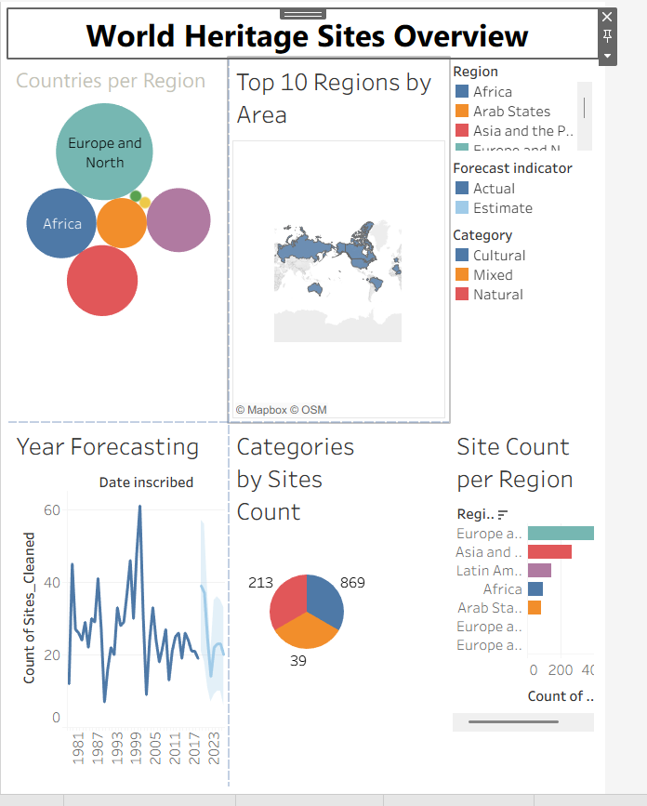
Story Point 1 — World Heritage Sites Overview (Countries per Region, Top 10 Regions by Area, Year Forecasting, Categories by Sites Count, Site Count per Region) — serves the Tourism Planner and Policy Researcher personas
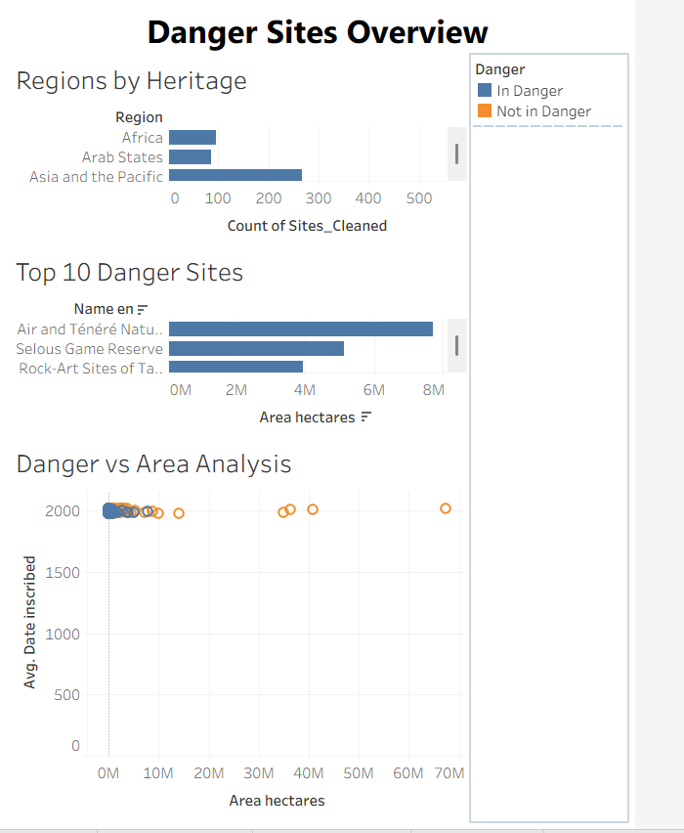
Story Point 2 — Danger Sites Overview (Regions by Heritage, Top 10 Danger Sites, Danger vs Area Analysis) — serves the Conservation Officer persona
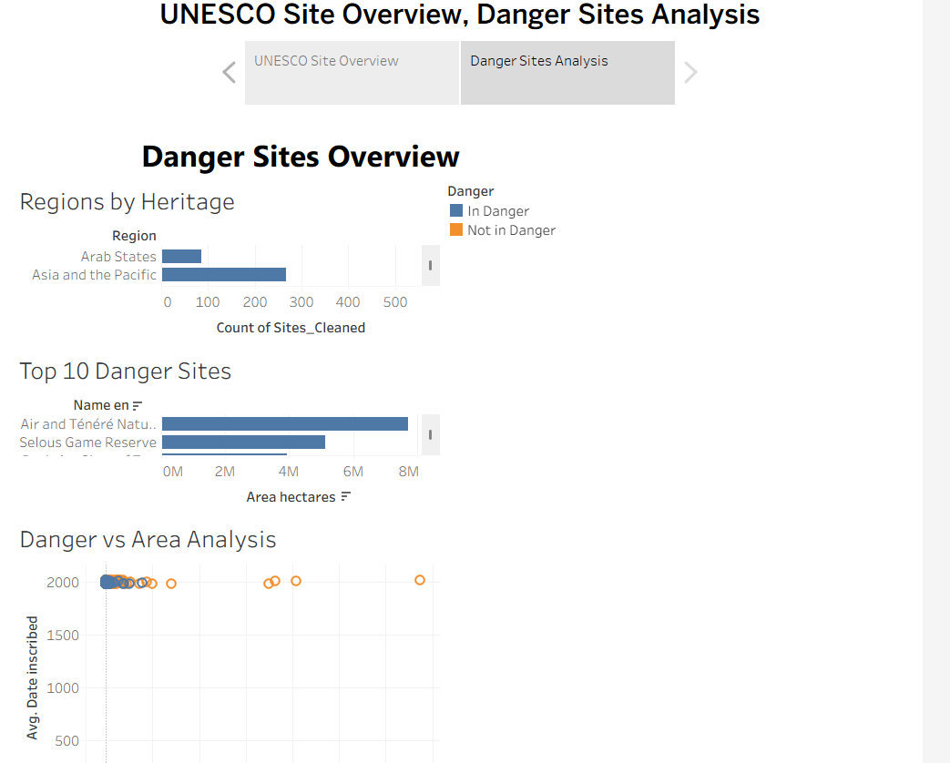
Tableau Story navigation — the UNESCO Site Overview and Danger Sites Analysis tabs link the two dashboard pages into a single guided Story

8. Advantages & Disadvantages
Advantages
- Zero-cost deployment: every tool in the stack (Tableau Public, GitHub) is free, with no server, license, or IT approval required.
- Role-specific dashboards mean each persona reaches a relevant view directly rather than filtering a generic report from scratch.
- Sub-3-second filter response on the ~1,121-site dataset, confirmed by Performance Testing, with no extraction or aggregation needed.
- No login barrier: the public Tableau link is accessible on any browser, which matters for stakeholders like Elena who need to share findings quickly with a funding committee.
- Cross-browser and mobile-view compatibility, validated in Chrome, Edge, and Safari.
- Clear traceability from persona pain points through requirements to shipped charts, keeping the workbook focused rather than feature-bloated.
Disadvantages
- The dataset's Danger Status and site records extend only to 2019, so more recent inscriptions or delistings are not reflected without a manual data refresh.
- Danger List causes (conflict, natural disaster, development pressure) are not broken out as a separate dimension, so the dashboards show that a site is in danger but not why.
- Latitude/Longitude and Area fields exist in the schema but were not used for a dedicated site-size or density view in this phase, limiting drill-down granularity.
- Tableau Public workbooks are visible to anyone with the link, which is appropriate here since the dataset is public, but would not suit a project involving sensitive data.
- As a five-person team project, work was distributed by epic rather than reviewed end-to-end by a single owner, so a final cross-dashboard consistency pass beyond the documented Performance Testing is recommended before wide distribution.

9. Conclusion
This project demonstrates how Tableau's visual analytics capabilities can transform a global heritage reference dataset into actionable insights for three distinct stakeholder groups. By tracing every chart back to a specific persona pain point identified during Ideation, and validating every functional and non-functional requirement during Performance Testing, the finished solution gives a conservation officer, a tourism planner, and a policy researcher each a dashboard suited to their own decision — without requiring any of them to install software, log in, or interpret raw reference tables. All eight performance test cases passed with no defects, and the workbook and full documentation set are version-controlled and publicly available via GitHub and Tableau Public.

10. Future Scope
- Integrate additional dimensions such as inscription criteria and protected area size for a more complete risk profile per site.
- Develop a predictive layer to flag sites at elevated risk of future Danger-List inscription.
- Build a country-level drill-down within each regional dashboard for more granular conservation planning.
- Cross-reference Danger List history with conflict and climate data for deeper causal analysis.
- Extend the analysis with World Heritage List updates as new sites are inscribed or removed from the Danger List, refreshing the existing workbook without redesigning any dashboard.
- Migrate from Tableau Public to Tableau Server or Tableau Cloud if the project moves from a team academic project to an institutional or NGO-hosted deployment, enabling authenticated, higher-frequency data refreshes.

11. Appendix
Dataset Link
Kaggle UNESCO World Heritage Sites Dataset, 1978–2019 — approximately 1,121 sites, 12 fields, covering Category (Cultural / Natural / Mixed), Country, Region, Year Inscribed, and Danger List status.
GitHub & Project Demo Link
- Tableau Public workbook (all dashboards + Story): https://public.tableau.com/app/profile/manku.deepika5282/viz/HeritageTreasuresAnIn-DepthAnalysisofUNESCOWorldHeritageSites2019/UNESCOSiteOverviewDangerSitesAnalysis
- GitHub repository (documentation + deliverables): https://github.com/mankudeepika123-rgb/Heritage-Treasures-An-In-Depth-Analysis-of-UNESCO-World-Heritage-Sites-2019-

11.1 Individual Chart Views
The six charts below are close-up views of the individual worksheets that make up the two dashboard pages shown in Section 7.1, included here for readability.
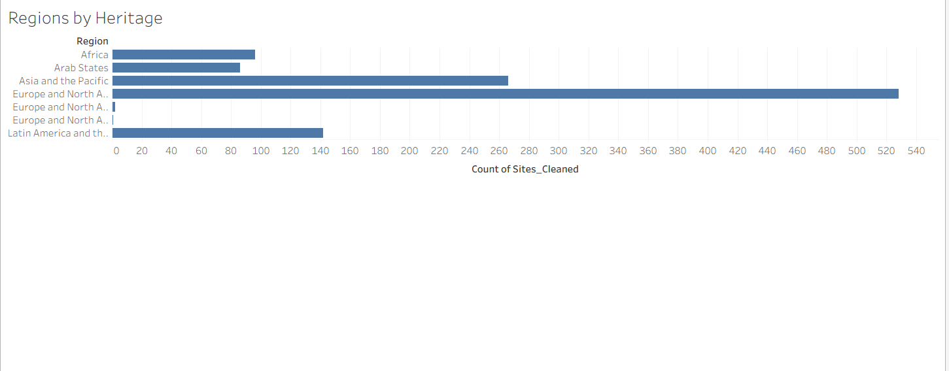
Regions by Heritage — count of sites by region, from the Danger Sites Overview page
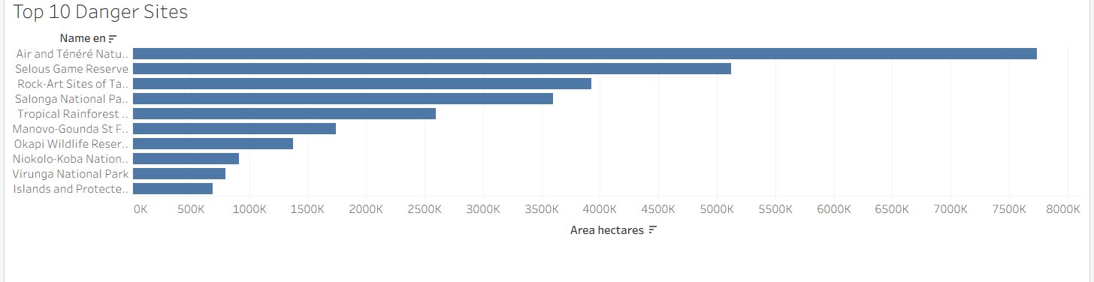
Top 10 Danger Sites — largest sites currently on the Danger List, from the Danger Sites Overview page
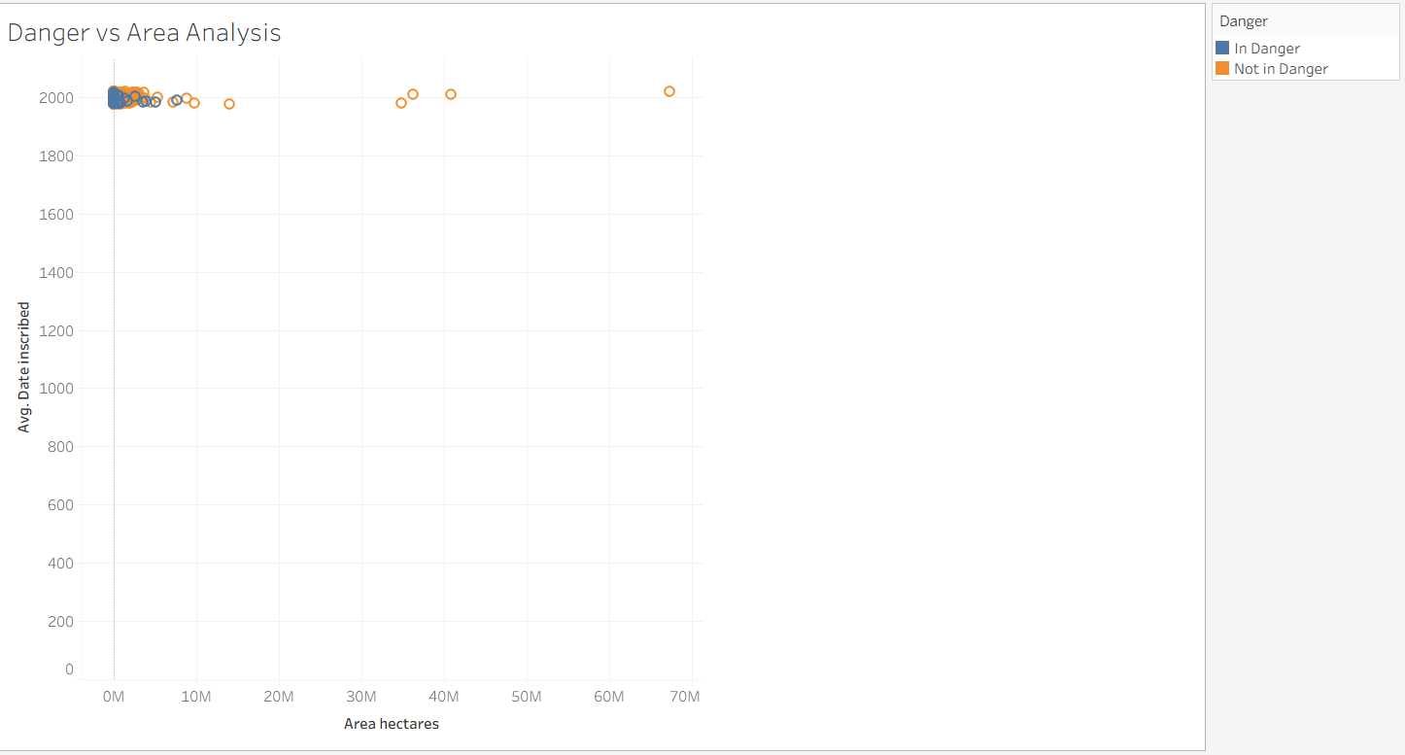
Danger vs Area Analysis — inscription year plotted against site area, from the Danger Sites Overview page
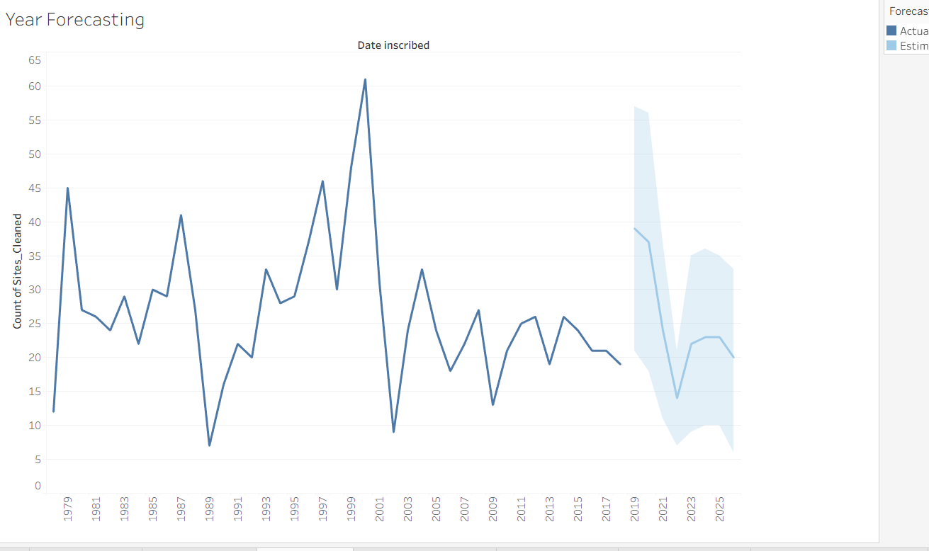
Year Forecasting — inscriptions per year with a forecast band, from the World Heritage Sites Overview page
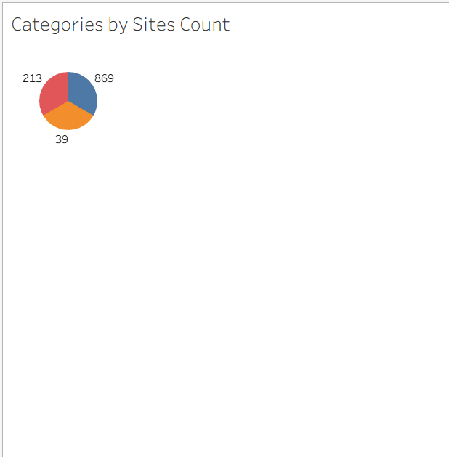
Categories by Sites Count — Cultural / Natural / Mixed site counts, from the World Heritage Sites Overview page
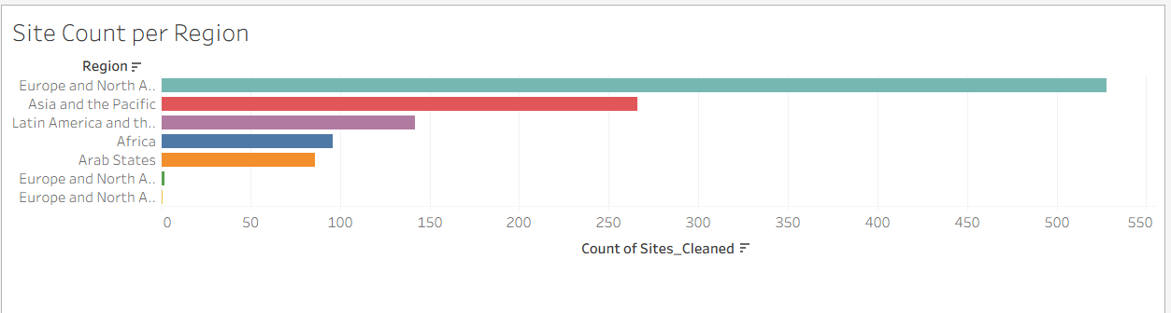
Site Count per Region — sites by region, from the World Heritage Sites Overview page

